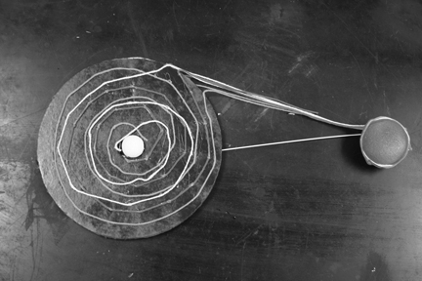
Binary Star Model

Make a physical model of a binary star system that demonstrates the components of which it is made, including the accretion disk.

Goal
Demonstrate what a binary star system with an accretion disk looks like so students have a visual understanding of size and shape.

Materials

Two Styrofoam balls – Make balls appropriate size depending upon whether they
are white dwarf, red dwarf, red giant or normal star.
Cardboard disk – Use stiff cardboard- gauge size relative to central star
Wire hanger – Use straight part of hanger to make a connection between the two
styrofoam balls.
Spray paint – Red, orange, yellow, dark brown, black, and/or a combination of
colors
Yarn – Red, orange, and/or yellow
Straight pins, glue, toothpicks, or other materials for attachment

Procedure

- Spray paint styrofoam balls the color of the stars desired, red, orange, yellow, or combination for the system being modeled.
- Cut out a circle of cardboard with 12-16 inch diameter and a small enough diameter hole in the middle to fit the central star (Styrofoam ball)
- Spray paint disk black, dark brown or a combination of colors. An alternative to this would be to paint the disk the colors of the “star materials” being pulled in by the central star from the orbiting star.
- Cut the wire hanger so that the straight part plus some of the upward bent section is available to insert into the Styrofoam balls. See diagram setup below.

cardboard styrofoam ball
disk wire hanger

- Connect with toothpicks or glue the central star styrofoam ball to the cardboard disk.
- Insert the wire hanger into both styrofoam balls
- Use the yarn to “swirl” out of the orbiting star (outer styrofoam ball) onto both the top and bottom of the cardboard accretion disk and in toward the central star (Styrofoam ball). Glue down the yarn.

