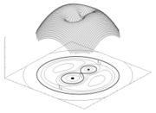
Interacting Binary Star System Activity
“Make a physical 3-D model of an interacting binary star system using light bulbs, meter, and a solar cell that will enable students to actively measure and record the luminosities of the system in different orientations, thus simulating real interacting binary star systems.”
Note: This activity should be used in conjunction with or as a supplement to the “Dark Matter in Accretion Disks” activity (DMAD). It will help students to learn more about light curves and create 3-D models that can be compared to Spitzer data from Z Cha and WZ Sge.

Vocabulary:
From DMAD:
Interacting binary star Accretion disc
Magnitude Binary star
Period Eclipsing
Red dwarf Light curve
Standard Star White dwarf

Lesson Objectives:
- Students will learn what variable stars are and by what processes astronomers study them. (Same as in DMAD)
- Students will use a solar cell, meter, and light bulbs to simulate an interacting binary star system.
- Students will understand how a binary star system's orbit can cause changes in the observed brightness of the system. (DMAD)
- Students will create a light curve using their data and compare it with authentic data of two variable stars, Z Cha and WZ Sge, taken from the Spitzer Space Telescope
- Students will describe what a light curve is and what information can be learned from a light curve. (DMAD)

Materials: (Per Group)
- Red cellophane (Blue for extended activity)
- Two small light bulbs
- Solar Cell
- Meter to read voltage from solar cell (voltmeter)
- Large piece of paper or White board
- Ruler or meter stick
- Computers with Excel-style program
- Data set from WZ Sge and Z Cha

I. Engage

The “Dark Matter in Accretion Disks” activity can be used as the basis for this activity. The sections “Engage” and “Explore” are good lead-ups for this activity: Making 3-D Models of Interacting Binary Systems.
II. Explore

- Explain that there are many different types of interacting binary star systems. Stars in these systems occur generally in pairs consisting of a white dwarf star and another type of star, usually a red giant or red dwarf. Remind students of where these types of stars fall in the perspective of stellar evolution and the Hertzsprung-Russell diagram.
- Show students the light curves from two interacting binary systems that were created from the infrared and visible light spectra taken with the Spitzer Space Telescope and ground based telescopes: WZ Sge and Z Cha. Explain that WZ Sge is a white dwarf star orbited by a brown dwarf star, and that Z Cha is a white dwarf orbited by a red dwarf.
- Tell students they are going to make a 3-D model using two light bulbs, a solar cell, and a voltmeter to simulate an interacting binary system and the light it emits. Give students the following instructions:
- Take the large piece of paper or whiteboard and draw a large circle on it. Make the circle have a radius of at least 8 inches or greater. Mark the center of the circle and at least 8 points of equal distance around the circle. The more points used, the better the light curve that will be produced. This circle will represent the “orbit” taken by the red dwarf star around the central white dwarf star.
- Cover one of the light bulbs with the red cellophane. Be sure that the entire bulb is covered so that no white light leaks out. Tape the cellophane edges down to the bulb, so that nothing obstructs the light that is being emitted. This light bulb will represent the red dwarf star that “orbits” the central white dwarf star.
- Next, place the white light bulb at the center of the circle drawn, so that it acts as the center “white dwarf” star in the interacting binary system. Place the red light bulb on the circle to be used as the orbiting star.
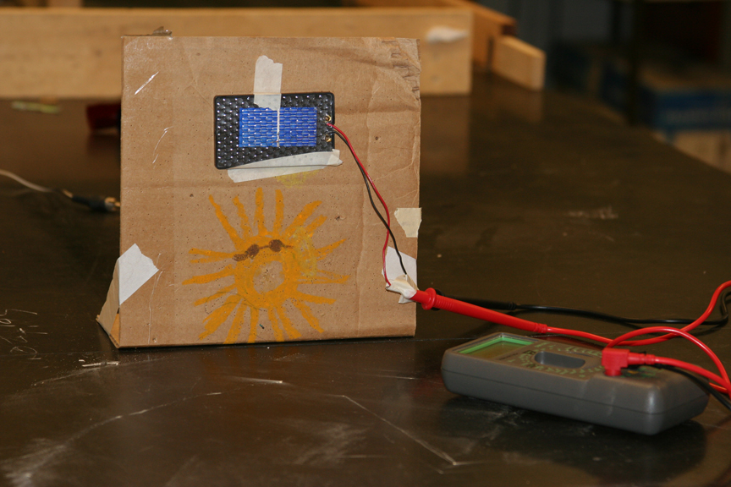
- Mount the solar cell on a non-moveable object facing the center of the circle. Connect the solar cell wires directly to the voltmeter and turn it on so that it reads “voltage”. (Note: You do not need a battery, since the solar cell will provide the power). The voltage number shown on the meter represents the “brightness” or “magnitude” of the star (light bulb) system.
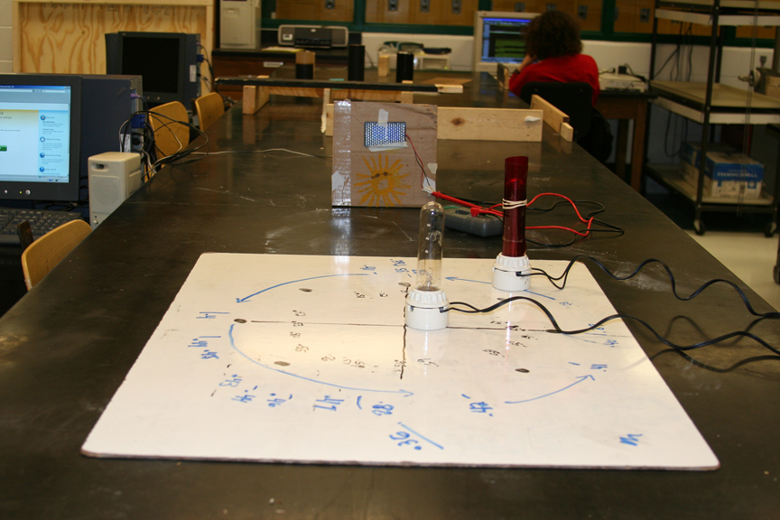
- Place the solar cell and voltmeter detector any distance away from the center of the circle. The solar cell should stay in this position for the entire “orbit” of the light bulb.
- Now with only one light bulb on at a time, use the solar cell to measure the individual voltage (magnitude) of each light bulb and record this value for each bulb.
- Next, set up the two light bulbs so that the red light bulb, representing the red dwarf, will be “orbiting” the white light bulb, representing the central white dwarf star.
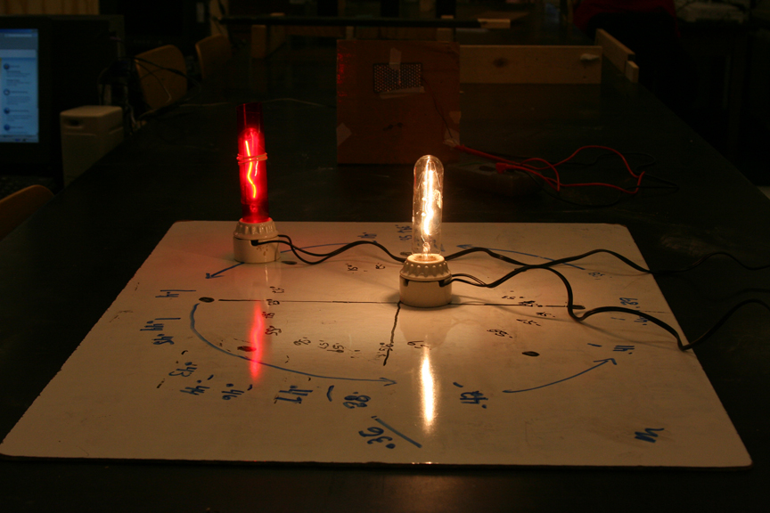
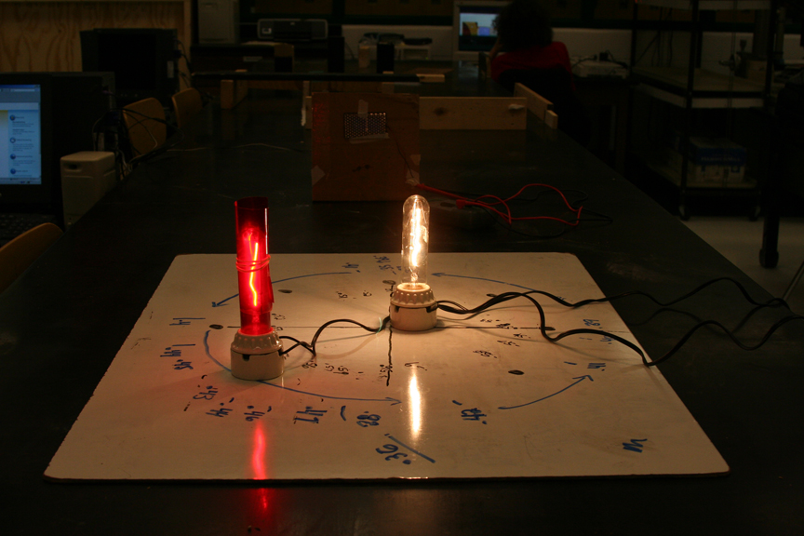
- Now, with both lights on, move the red dwarf around the white dwarf along the circle that was first drawn. Take the voltage (magnitude) measurements as the red dwarf orbits around the white dwarf at each of the 8 (or more) equal increments. This is the orbit. Make a table of the voltage versus location information.
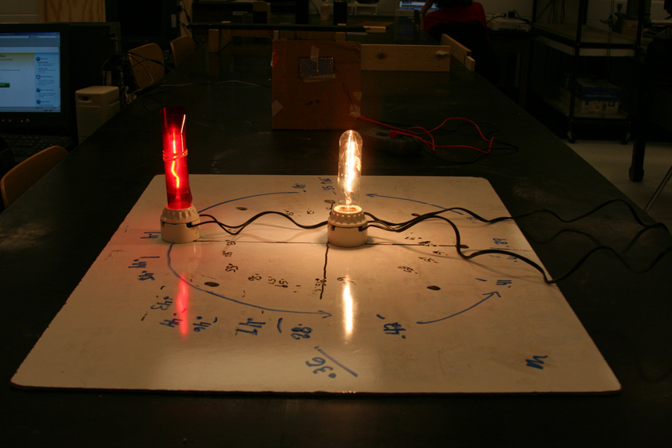
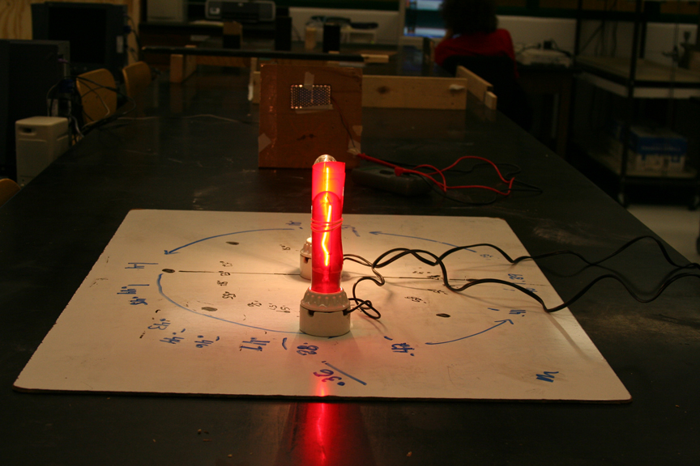
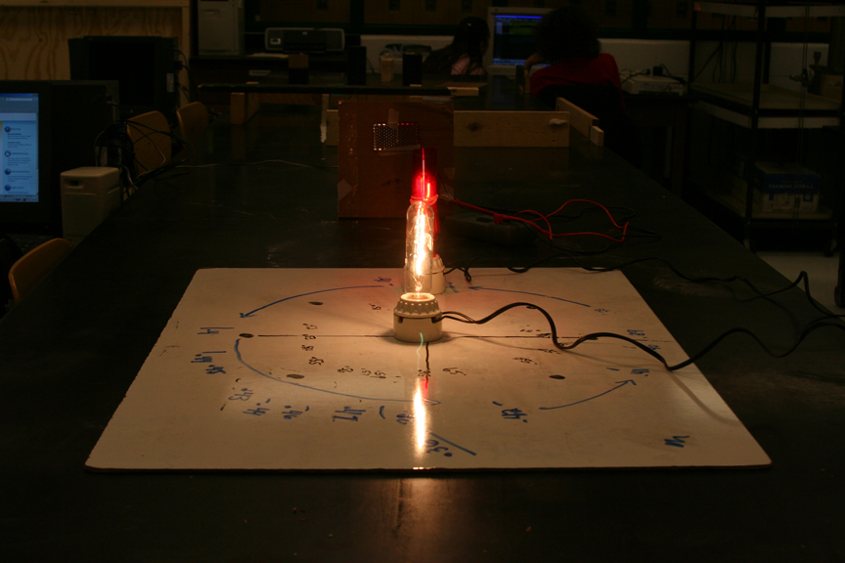
- Remind students to watch the change in voltage (magnitude) measurements carefully because there will be some positions around the orbit where the numbers will “blip” or change suddenly. Students might even want to take more measurements around these positions for a better graph.
- Direct students to record the position of the “red dwarf” and the change in overall "magnitude" or "brightness" of the “interacting binary system” as the “red dwarf” orbits the “white dwarf”. Ask students to record their observations, make a magnitude (brightness) versus location graph, and answer the following questions:
- How does the “magnitude” (brightness) of each individual star (light bulb) compare with the different colored cellophane?
- How does the magnitude of each individual star (light bulb) compare with the magnitude of the “system”?
- When is the “interacting binary system” brightest?
- When is the “interacting binary system” dimmest?
- Describe what happens to the brightness just before, just after, and when the red dwarf moves between the solar cell and the white dwarf.
- Explain why the shape of the light curve looks like it does and compare what is happening in the light curve to the physical 3-D model.

III. Explain

A light curve graphs the intensity or brightness of light that comes from an object in space, as a function of time. The “magnitude versus location” graphs made by students in this activity are very similar if the orbiting star location is equated to time, which it can be since the data was taken at 8 equal interval locations. If students were to graph the light produced by each light bulb by itself, it would be a flat line at a particular voltage (or brightness) value and remain unchanged over time. This type of measurement produces a light curve that doesn’t change and is called a “standard star”. In the case of eclipsing binaries, Cepheid variables, and other variable stars whose light curves are periodic, this activity models the changes in periodic brightness. However, some binary systems can be aperiodic, like in the case of nova, cataclysmic variables, or supernova. Light curves can be made in all electromagnetic wavelengths, not just visible light.

Studying light curves in addition to other forms of observation can produce information about the physical processes of stars, or constrain the physical theories of how stars or interacting star systems develop, evolve, or interact. Recording the relative changes in brightness of a star, to produce a light curve, can help astronomers to understand processes at work within the star (or stellar system) and identify specific categories of stellar events. When a light curve is made, it can be compared to that of a standard star (a star that does not change brightness) light curve or to light curves made in other electromagnetic wavelengths to identify features (such as accretion disks), system classification (type of system), or other system properties worth study.

In the case of Z Cha, the light curve in the mid-infrared spectra compared the light curve in the optical observable-light spectra yielded information regarding the size of the accretion disk that surround the central star that no one knew about previously. Astronomers do light curve comparisons all the time to learn some information that might be useful. Let’s look at a curve and see what in it might be useful information.

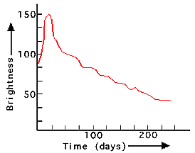
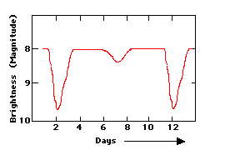
If the light curve measured in this activity looked like the graph at the right, then the system being observed might be identified as an eclipsing binary star. We can say this because the light curve shows “dips” where light is being blocked by something passing in front of it. Check out your light curve and see if it has any “dips”. Other things can be learned from this light curve. Look at the x-axis and notice that it takes 10 days for one of the stars in the binary to orbit completely around the other. Astronomers would say, "the orbital period of the binary system is 10 days."

Look at this light curve to the right. This light curve does not provide an orbital period, so astronomers would have to observe it for a longer period of time to obtain that information. Also note that this object might not be a binary star system at all. It may be the light curve of an aperiodic object, like a supernova or something like that.

IV. Elaborate

Part I
This activity can be extended to explain and demonstrate other types of variable binary star systems. Students can create different light curves by applying the following changes to their 3-D model.

  - Students can use different colored cellophanes on different star locations, such as a red or blue central star with a white orbiting star or vice versa.
  - Students can place the solar cell and voltmeter detector at different distances, very close versus very far (across the room) away from the binary star system.
  - Students can place the solar cell and voltmeter detector at different angles relative to the orbital plane of the binary star system. Orientations might include over-head, at a 45-degree angle, or edge on.

Part II

As a challenge, use the 3-D model to try and make a Light Curve that matches authentic Spitzer Space Telescope data.

- Look at the light curves for the two variable stars, WZ Sge and Z Cha. These light
curves were taken by the Spitzer Space Telescope in the infrared and by ground based telescopes in visible light.
- Place the solar cell and voltmeter detector in different locations above, to the side, and at different angles to the plane of the orbit in order to create light curves that are similar to or match each of the real light curves for WZ Sge and Z Cha.
- Another method would be to exchange the locations of the red and white light bulbs or to change the color of the cellophane filters between red, white, blue or other available colors.
- Plot the orbits and make light curves of the different filtered light bulbs and detector orientations. Determine which combination produces light curves that are the closest to the real light curves for WZ Sge and Z Cha.
- Use the light curves you made from the 3-D models to explain what might be happening in the authentic light curves from Spitzer and ground based observations.

V. Evaluation

Using your completed light curves, you are to submit a report to the research team at the Spitzer Science Center in Pasadena, California about the relationships between the light curves and the location of the solar cell detector.
When you are done with your research, we'd like you to write a report describing what you learned about interacting binary star systems and answering the following:
- How did the light curves of standard stars compare to the light curves of interacting binary systems?
- What did you notice about where the solar cell detector needed to be located in order to obtain a similar light curve to the ones provided for WZ Sge and Z Cha?
- Which light curves were the easiest to duplicate and why?
- Describe what is happening in an interacting binary star system that produces the observed changes in brightness.
- Which orientations of the binary produce maximum/minimum light?
- For the light curves that could not be recreated, speculate what might be happening in the interacting binary star system for the observed changes in brightness.
- Explain why, even though, there are two stars, the brightness changes.
- What can scientists learn about an interactive binary system after graphing its light curve?
Background Information For Teachers:

Variable stars are more interesting than they may originally appear to be. There are many types of variable stars. Some are single stars that vary in brightness due to the point in stellar evolution that they are at, exploding, or because they have become unstable brightening and dimming as they literally change size. Some variable stars are really part of a pair of stars that change brightness because one star passes in front or behind another star. Some of these types of binary star systems are periodic with very short brightness changes that can occurs within hours and others that take much longer periods of time like years.

Astronomers study variable stars and interacting binary star systems for many reasons, to learn more about stellar evolution or to discover the mysteries associated with finding dark matter and dark energy. Eclipsing binary stars are a rich source of information about the physical properties (mass, size, luminosities, internal structure, etc.) of stars and their evolution through time. Often the masses and sizes of the stars are known to better than 1% accuracy. Cataclysmic variable stars are close binary stars consisting of a late-type star and white dwarf. Mass is being transferred from the late-type star to the white dwarf. Unless the white dwarf has an extremely strong magnetic field, the transferred mass forms an accretion disk around the white dwarf. Because of the instabilities caused by the white dwarf pulling mass off of the late-type star, eruptions can occur causing the system‘s brightness to change.

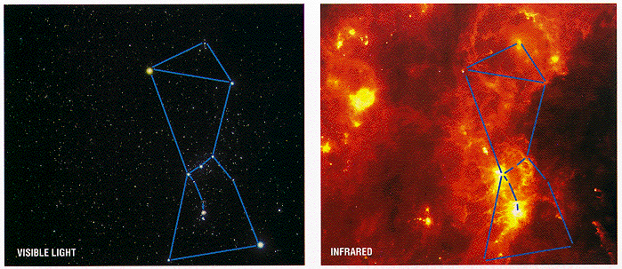
Astronomers use many tools to learn what they can about these objects. The most important is the electromagnetic spectrum. The electromagnetic spectrum includes long wavelengths such as radio, microwave, and infrared to short wavelengths including visible, ultraviolet, x-rays, and gamma rays. Each wavelength in the electromagnetic spectrum yields different information about the object being studied. One of NASA's current astronomy projects is the Spitzer Space Telescope (formerly called SIRTF). The Spitzer Space Telescope was launched into space in August 2003 to study our solar system, galaxy, and the universe. Spitzer is the fourth and final observatory in NASA's family of Great Observatories that include the visible light Hubble Space Telescope, the Compton Gamma-Ray Observatory, and the Compton X-Ray Observatory. Each observatory uses a different electromagnetic wavelength to study objects. The Spitzer Space Telescope is designed to both take images and spectra using infrared wavelengths beyond 7000 Angstroms at 3 and 180 microns. A micron is a millionth of a meter.

The importance of using authentic data from instruments like Spitzer in the classroom, together with models is a good way of conceptualizing what astronomers hypothesize. Often multiple wavelength data can be used to discover things that were previously unknown. As an example, look at these images of the constellation Orion. In the visible light image on the left, only the brightest stars can be seen, but in the infrared image, on the right taken with the Spitzer Space Telescope, regions of gas previously unseen appear providing astronomers with information about star forming regions previously unknown to exist.

The Spitzer Space Telescope is the primary tool used in the study of cataclysmic variable stars addressed in this lesson and it’s extensions: “Dark Matter in Accretion Disks” and “Binary Star Model”. The two cataclysmic variables primarily used to inspire and create these lessons were WZ Sge, in the constellation Sagitta, and Z Cha, in the southern constellation Chamaeleontis. In 2007, WZ Sge, a brown dwarf orbiting a white dwarf, was first observed to reveal that the mass and radius of the accretion disk were far greater then currently believed and modeled (based on optical and UV observations) over the past few decades. The preliminary findings of WZ Sge suggested that the accretion disk contains a large, cool outer ring likely to extend to a far greater radius and contain perhaps 1-2 times more mass than currently believed. These observations have great relevance for accretion disks in general, those in binary systems as well as in active galaxies.

The observations of Z Cha in 2008 taken by Spitzer were designed to provide observations that will test and confirm the WZ Sge findings. The multi-wavelength data was obtained from both the Spitzer Space Telescope and optical B-band light curves from CTIO (0.9 m) in Chile. Data was collected for Z Cha at 4.5 and 8.0 microns on May 14, 2008 by Spitzer and March 28 2008 from CTIO. Z Cha is an eclipsing system containing a white dwarf as the primary star and a red dwarf as the secondary, donor star. It is a non-magnetic system with an orbital period of 1.788 hours. It is 313 light years away. As Z Cha is a nova-like cataclysmic variable, it has a relatively high rate of mass accretion and thus the disk is optically thick. Comparisons of the light curves of WZ Sge and Z Cha reveal similar, but slightly different information about each disk; most importantly revealing that an additional component is present, the most likely explanation for which is warm dust.
The graph to the right was created from the reduced photometric data collected from the 0.9-meter telescope at CTIO in Chile. Students created this light curve and this data was used for comparison with the data produced from the in-class lab activity shown below.

Note the similarities of the Spitzer generated light curve with those produced by the lab activity. Much can be learned by modeling the authentic data. Ask your students to model the data and answer the question: What orientation does the experiment 3-D model need to be in to help us make predictions and further explain this system?

