2.3 PART I — HIDDEN MESSAGES

Name____________________________________ Date______________ Period_______

White light, like the light from the Sun or a light bulb, is made up of many different colors. In this activity, you will explore light and color.

MATERIALS: Red and blue crayons, sheets of white, red, and black construction paper, and red and blue “gels" (a gel is simply a sheet of transparent colored plastic).

A. Predict what color, if any, you will see when you look at a blank white, red, and black sheet through the red gel and through the blue gel.

 |  | blank white sheet | blank red sheet | blank black sheet
red gel | Predicted | Answers will vary | Answers will vary | Answers will vary
red gel | Observed | red | red | black
blue gel | Predicted | Answers will vary | Answers will vary | Answers will vary
blue gel | Observed | blue | black | black

Explain your reasoning for the predictions you just made.

Answers will vary.

- Isaac Newton, a seventeenth century scientist, discovered that white light contains all colors. You might have seen this if you’ve ever directed white light (such as a flashlight, a slide projector beam, or sunlight) through a prism. Another example is a rainbow in the sky, which is created when water droplets in the atmosphere act like a prism and separate sunlight into its colors.

1. According to Newton’s theory, what colors of light are bouncing off the white sheet and entering your eye (when no gel is present)?

All colors of light are bouncing off the sheet and entering your eye when no gel is present.

- Now, look at the blank sheet of white paper through the red gel. Write the color you see, if any, in the appropriate column of the table above. Did this match your earlier prediction?
White paper viewed through the red gel looks red because the red gel absorbs (or blocks) all the other colors reflecting off the white paper, keeping them from reaching your eye. Only the red light can pass through the gel, so the paper looks red.

- Use the red and blue crayons to complete the diagram below, showing the path that each color of light travels after it is reflected from the white paper through the red gel to you eye.

red gel light source

Blue mark Red mark

white paper

The diagram should show red light bouncing off the paper, passing through the gel and entering the eye. Blue light bounces off the paper, but is absorbed or stopped by the gel and does not enter the eye.

- Predict what you will see if you look at a blank sheet of RED paper through the BLUE gel and write your prediction in the table. Explain your reasoning using a sketch if necessary. Then test your prediction and write what you see in the table.

The red paper reflects only red light. The blue gel absorbs or blocks the red light (only blue light can pass through the gel). Thus no light gets through the gel, and the red paper looks black when viewed through the blue gel.

- Look at a blank sheet of black paper through the red gel. Write down what you see in the table. Did this match your prediction? Repeat with the blue gel.

The black paper should look black through the red gel and through the blue gel. No light reflects off the black paper, so there is no light to pass through the gels. Note that the black paper may not look perfectly black because of scattering, color variations in the paper, and gel density.

- Consider the following statements from two students:

Student #1: I’ve heard that black is a combination of all colors. So, when we look at something that appears black, we’re seeing all the colors mixed together.

Student #2: I’ve heard that black is the absence of all colors. So, when we look at something that appears black, we’re not seeing any reflected light.

State whether you agree or disagree with EACH student and use your observations in explaining your choices.

Disagree with Student #1. White is made up of all colors mixed together, as we saw when we looked at the same white paper with the red and blue gels. Both red and blue light were reflected from the white paper.
Agree with Student #2. Black is the absence of all colors, as we saw when we looked at the same piece of black paper with the red and blue gels. Neither red nor blue light was reflected from the black paper. No color is reflected from the black paper.

- With one crayon, write the same message on both the white and the black blank sheets of paper. With the other crayon, on each sheet, write a second message directly on top of the first, so that the first message is partly covered by the second. It is okay if, when you are done, you are not able to clearly read the two messages.

Predict which message you will be able to read, if any, when you look at the white sheet and the black sheet through the red gel, and then through the blue gel.

 |  | which message you will see on white paper | which message you will see on black paper
red gel | Predicted | Answers will vary | Answers will vary
red gel | Observed | blue | red
blue gel | Predicted | Answers will vary | Answers will vary
blue gel | Observed | red | blue

- Test your predictions by looking at the messages with each of the gels. Explain why the red gel reveals the message that it does for each sheet of paper.

When you look through a red gel at a message written with a blue crayon on white paper, the blue light reflected off the crayon is absorbed by the red gel, and the writing looks black against the background. On the other hand, red light reflected off the red crayon message mixes with the red light reflected from the white paper, making it hard to distinguish the red message from the background paper. Thus, it is easier to see the blue message (which appears black) on the white paper through the red gel.

When you look through a red gel at a message written with a blue crayon on black paper, the writing still looks black, but it is now seen against a black background (since the black paper doesn’t reflect any light it appears black, no matter what gel is used). On the other hand, the red light reflected off the red crayon message passes through the gel and appears as a brighter red against a black background. So, you should more easily see the red message (which appears red) on the black paper through the red gel.

- When you looked at the messages on the white and black paper through a gel, you could read one of the two messages, without it being obscured by the other message. Astronomers use gels, which they call "filters", in a similar manner when they look at the sky. Sometimes when an astronomer wants to look at a particular star or nebula, he or she will use a filter to select part of the light from that star or nebula to study to highlight specific features of visible in that one color.

Go to the following web site: http://www.sofia.usra.edu/Edu/materials/activeAstronomy/crabnebula.html
(This image is also included in the “Images File” on the CD-ROM)

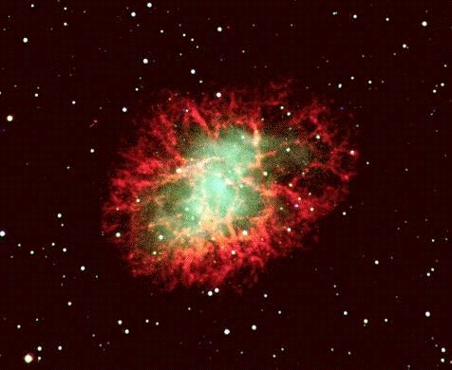
Image copyright ©1995 by Sven Kohle and Till Credner.

1. If you only wanted to look at the center of the nebula, and didn’t want to be distracted by the light coming from the outer edges of the nebula, which gel do you think you should use, red or blue? Explain your reasoning.

Blue. The outer parts of the nebula are red, while the inner parts are blue. Because the background of the picture is black, you would use a blue gel to see the blue inner parts.

2. Look at the picture on the computer screen through the gel. Was your prediction correct?

Answers will vary.
PART II — HIDDEN STARS

Name____________________________________ Date______________ Period_______

In Part I of this activity, you placed gels between your eyes and the objects at which you were looking. This blocked some of the colors of visible light from reaching your eyes. Sometimes, however, things exist between us and the objects we wish to observe that block all the visible light from reaching our eyes.

A. Look at the picture entitled "Visible Light View of a Hot Toaster.” It shows a toaster covered with a plastic bag. As you can see, the plastic bag blocks all the visible light bouncing off the toaster. Does this mean that the plastic bag will block all wavelengths of the electromagnetic spectrum?

No. Just because the plastic bag blocks visible light does not mean it will block all other wavelengths of the electromagnetic spectrum.

B. Now look at the picture entitled "Infrared Light View of a Hot Toaster.” It shows the same toaster, but this picture was taken with a camera that detects infrared light.

1. Draw a sketch of the toaster with the bag in front of it, showing what is happening in both the visible light and infrared light ranges of the electromagnetic spectrum.

The sketch should show the toaster, the plastic bag and a camera. Visible light coming from the toaster is absorbed by the plastic bag and doesn’t pass through it to the camera. Infrared light, on the other hand, passes through the plastic bag and enters the camera.

2. With your group, think of any differences or similarities between what happened when you looked through the gels in Part I of this activity and what happened with the plastic bag in these pictures. Draw a Venn diagram for the gels and the plastic bag.

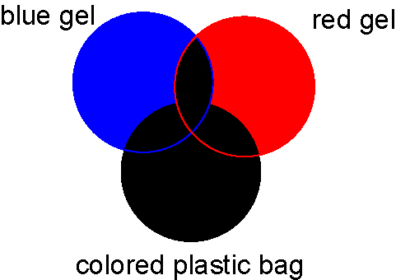

- Plastic bags aren't the only things that are opaque to visible light, but allow infrared light to pass through. The URL: http://www.sofia.usra.edu/Edu/materials/activeAstronomy/multiband-logo.html (this image is also included in the CD-ROM) shows two pictures of the same thing, one taken with a standard video camera and one with a camera that detects infrared light. Explain why can't you see the SOFIA logo in the photo taken with visible light.

The logo is covered by the fabric, which is opaque to visible light coming from behind it. However, it is not opaque to infrared light emitted by the paper, which can be detected by an infrared-sensitive camera.

- Recall that infrared light is not visible to the naked eye, and that it corresponds to the energy given off by thermal radiation or heat. Write down as many actual uses of infrared light and cameras that register infrared light that you can think of.

Among the uses listed may be: TV remote, car-locking system, grocery store check-out scanners, computers (to read CD-ROMs), night vision goggles, search and rescue monitors, weather satellites, fire-fighting (to see where fires are), keep food warm at restaurants, astronomical observations, environmental monitoring, medical scanning, looking for places where heat is lost from buildings

- In space, there are small particles of dust called interstellar dust, because the dust particles float in the nearly empty spaces between the stars. This dust behaves like the plastic bag and the striped cloth in the pictures. It is opaque to visible light, but allows other parts of the electromagnetic spectrum to pass through, most notably infrared light.

1. Complete the sketch below showing the effect of interstellar dust on the light from a star. Show the path that visible light takes once it leaves the star, and the path that infrared light takes.
dust
star
Earth

(not to scale)

visible

infrared

The diagram should show visible light coming from the star, and being scattered out of the line of sight from the star to the Earth by the dust. Infrared light, however, will leave the star, pass through the dust cloud and come straight to Earth.

2. Explain why an astronomer would use an infrared telescope to look at the star.

Since infrared light can pass through the dust cloud without being scattered, astronomers will be able to study infrared light from the star to learn about the star. Looking at the star with a visible-light telescope will reveal only the dust cloud, and no information about the star behind it.

